Q1.
Answer is A.

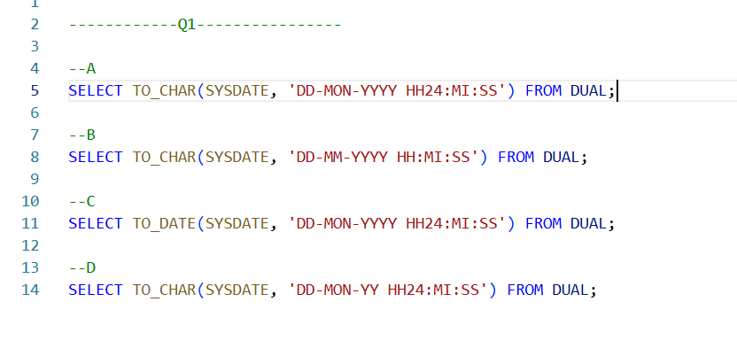

A: Correct.
Because it properly uses TO_CHAR to format SYSDATE with the required format.

B: Incorrect.
uses MM instead of MON, which would give the numeric month, not the 3-letter abbreviation.

C: Incorrect.
uses TO_DATE, which is not suitable for formatting an already existing date.

D: Incorrect.
uses YY for the year, which results in a 2-digit year instead of the required 4-digit year.

Q2.
Answer is A.

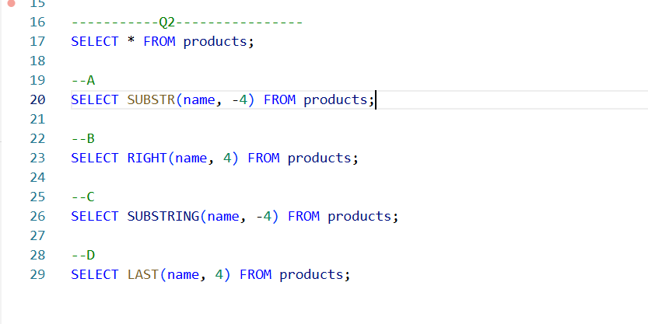

A: Correct.
The SUBSTR function is commonly used to extract a substring from a string.

B: Incorrect.
Valid in SQL server and MySQL.

C: Incorrect.
Invalid syntax.

D: Incorrect.
Invalid syntax.

Q3.
Answer is A.

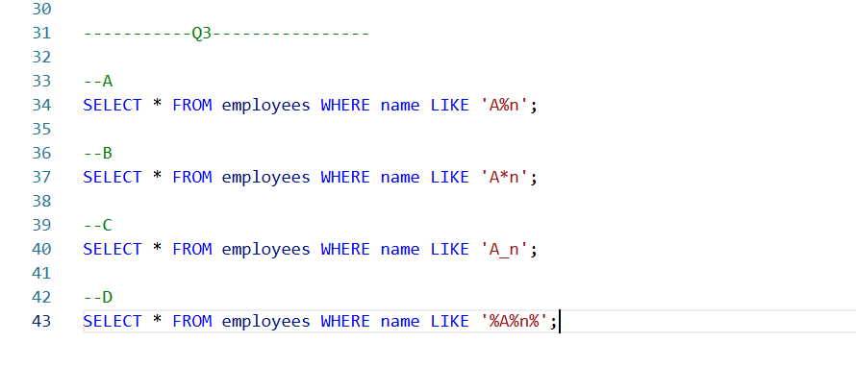

A: Correct.
it exactly matches names that start with 'A' and end with 'n', with any number of characters in between.

B: Incorrect.
due to the use of * instead of %, which is not valid in SQL for pattern matching.

C: Incorrect.
because it requires exactly one character between 'A' and 'n', which is too restrictive.

D: Incorrect.
because it allows 'A' and 'n' to appear anywhere in the string, not just at the beginning and end.

Q4.
Answer is A and C.

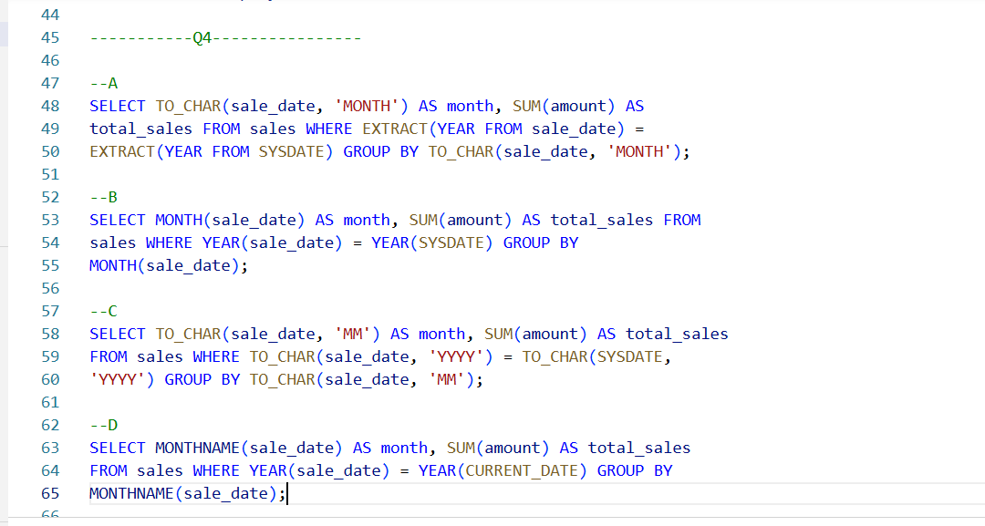

A: Correct. Valid query.

B: Incorrect. Work in MySQL but not work in Oracle.

C: Correct. Valid query.

D: Incorrect. Invalid query.

Q5.
Answer is B and C.

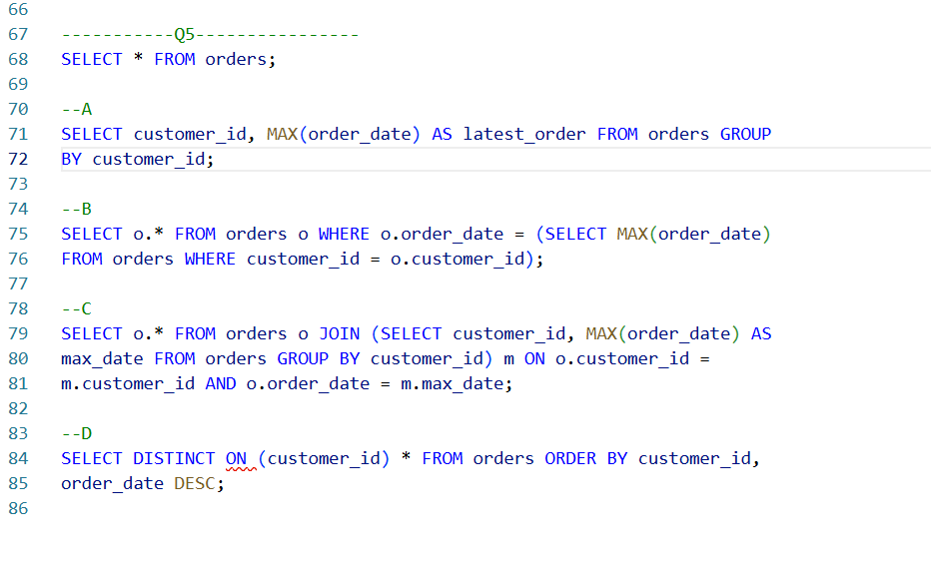

A: Incorrect.
it doesn't return the full order details like order_id or any other columns.

B: Correct.
uses a subquery to match the most recent order for each customer and returns the full details for that order.

C: Correct.
the most recent order for each customer and includes all columns from the orders table.

D: Incorrect.
only works in PostgreSQL.

Q6.
Answer is A.

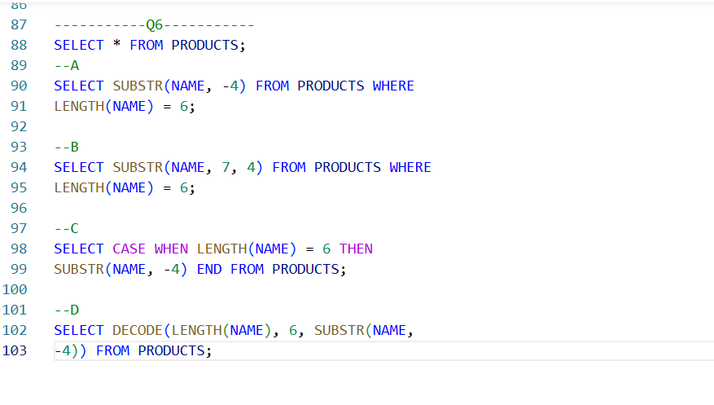

A: Correct.
extract the last 4 characters from a 10-character product code.

B: Incorrect.
but uses a slightly less intuitive method of specifying the substring position.

C: Incorrect.
This query will correctly extract the last 4 characters for PRODUCT_CODE values that are 10 characters long and return NULL for others.

D: Incorrect.
Also work like C.

Q7.
Answer is A.

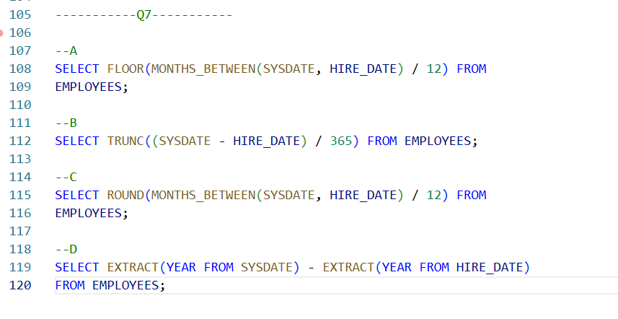

A: Correct.
It converting that to years, and rounding down to the nearest whole number.

B: Incorrect.
It doesn't account for leap years, making it less reliable.

C: Incorrect.
rounds to the nearest year, which is not always what we want when you need to round down.

D: Incorrect.
it doesn't fully account for the number of months and days between the dates.

Q8.
Answer is B.

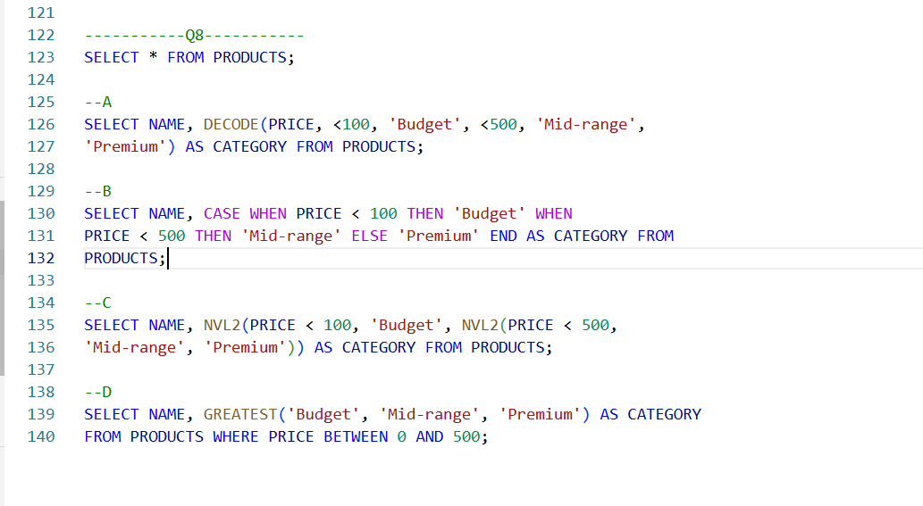

A: Incorrect. Invalid syntax.

B: Correct.
uses the CASE statement to categorize the products based on the price range.

C: Incorrect.
due to the misuse of the NVL2 function with boolean conditions.

D: Incorrect.
GREATEST is used incorrectly for categorization and the WHERE clause is overly restrictive.

